**Fluocell – Diffusion Module User’s Guide**

**Installation**

1. Download and unzip the diffusion module to a folder on your computer, for example, in the folder “D:\sof\diffusion_analysis\”. Download the sample data from this web link (<http://wang.ucsd.edu/~kalu/index.php> ) to a local folder that is readable by the user, say, “D:\sof\data\diffusion_sample\”.
2. Add the paths of diffusion module source code to MATLAB to allow recognition. In MATLAB, select: File 🡪 Set Path 🡪 Add Folder with Subfolders 🡪 “D:\sof\diffusion_1.1\src” , and “D:\sof\diffusion_1.1\app”.
3. Edit the file “sample_diffusion_init_data.m” such that the line

root = 'D:\sof\data\diffusion_sample\' ;

is changed to the current location of your sample data;

**Forward Simulation**

>> cell_name = 'photobleach_cell';

>> data = sample_diffusion_init_data(cell_name);

>> data = computer_simulation(data, 'dt', 0.25, 'simulation_time', 40);

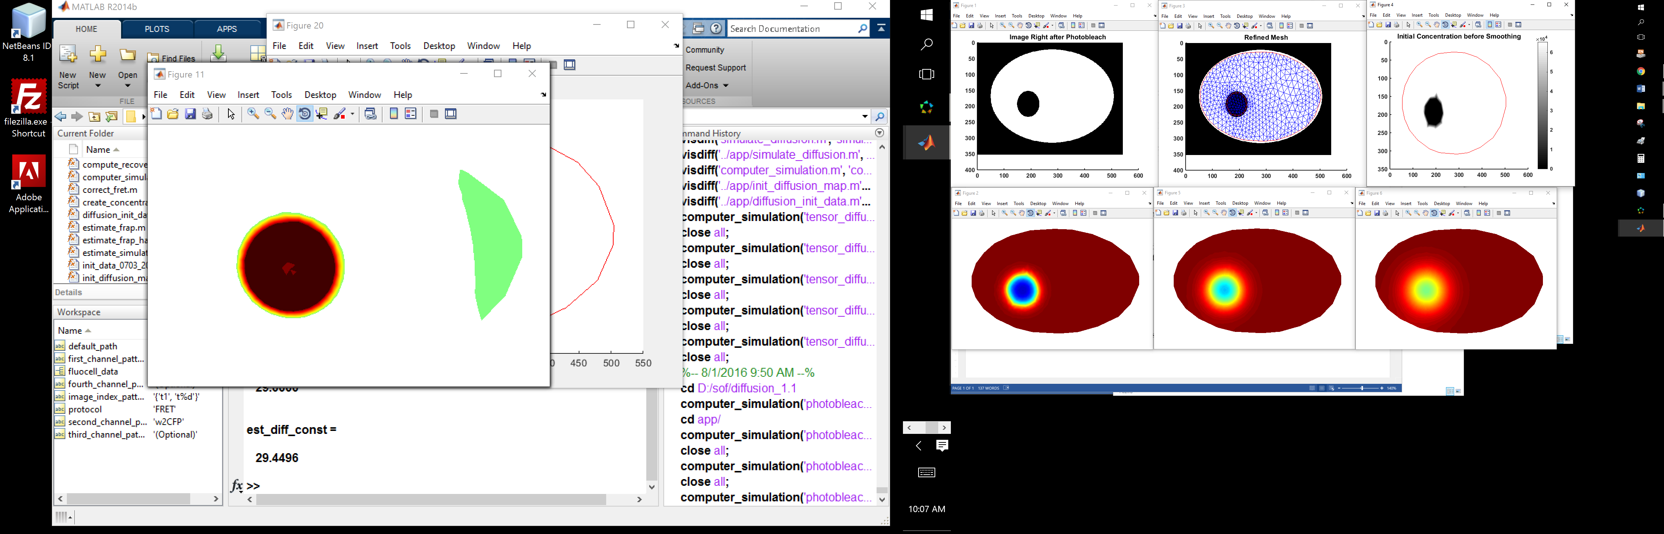

The parameter information of the FRAP and FRET experiments can be found in the database file: sample_diffusion_init_data.m

>> close all; clear all;

>> data = sample_diffusion_init_data('layered_diffusion');

>> computer_simulation(data, 'dt', 0.25);

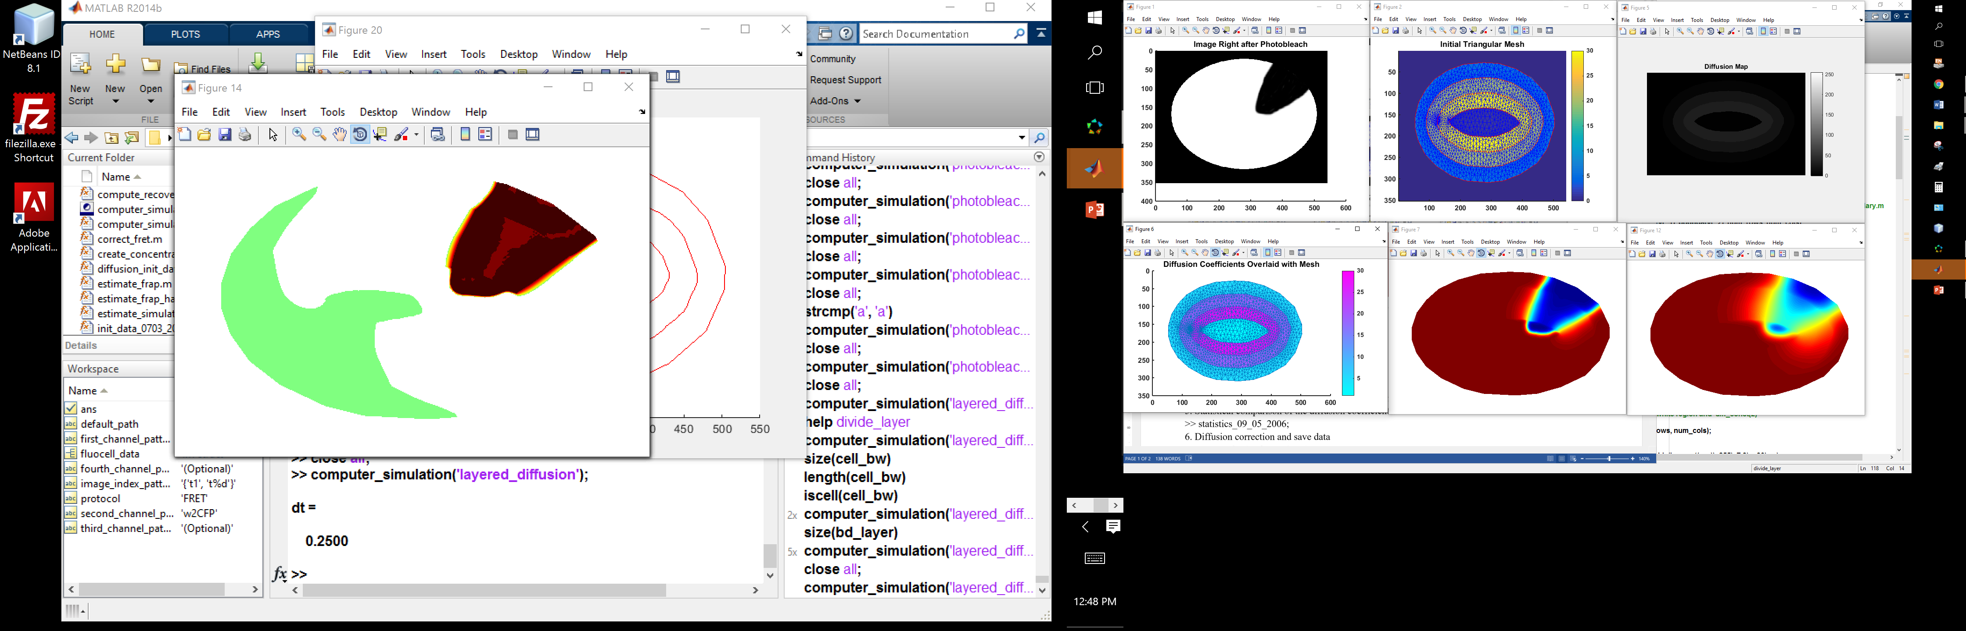

>> data = sample_diffusion_init_data('tensor_diffusion');

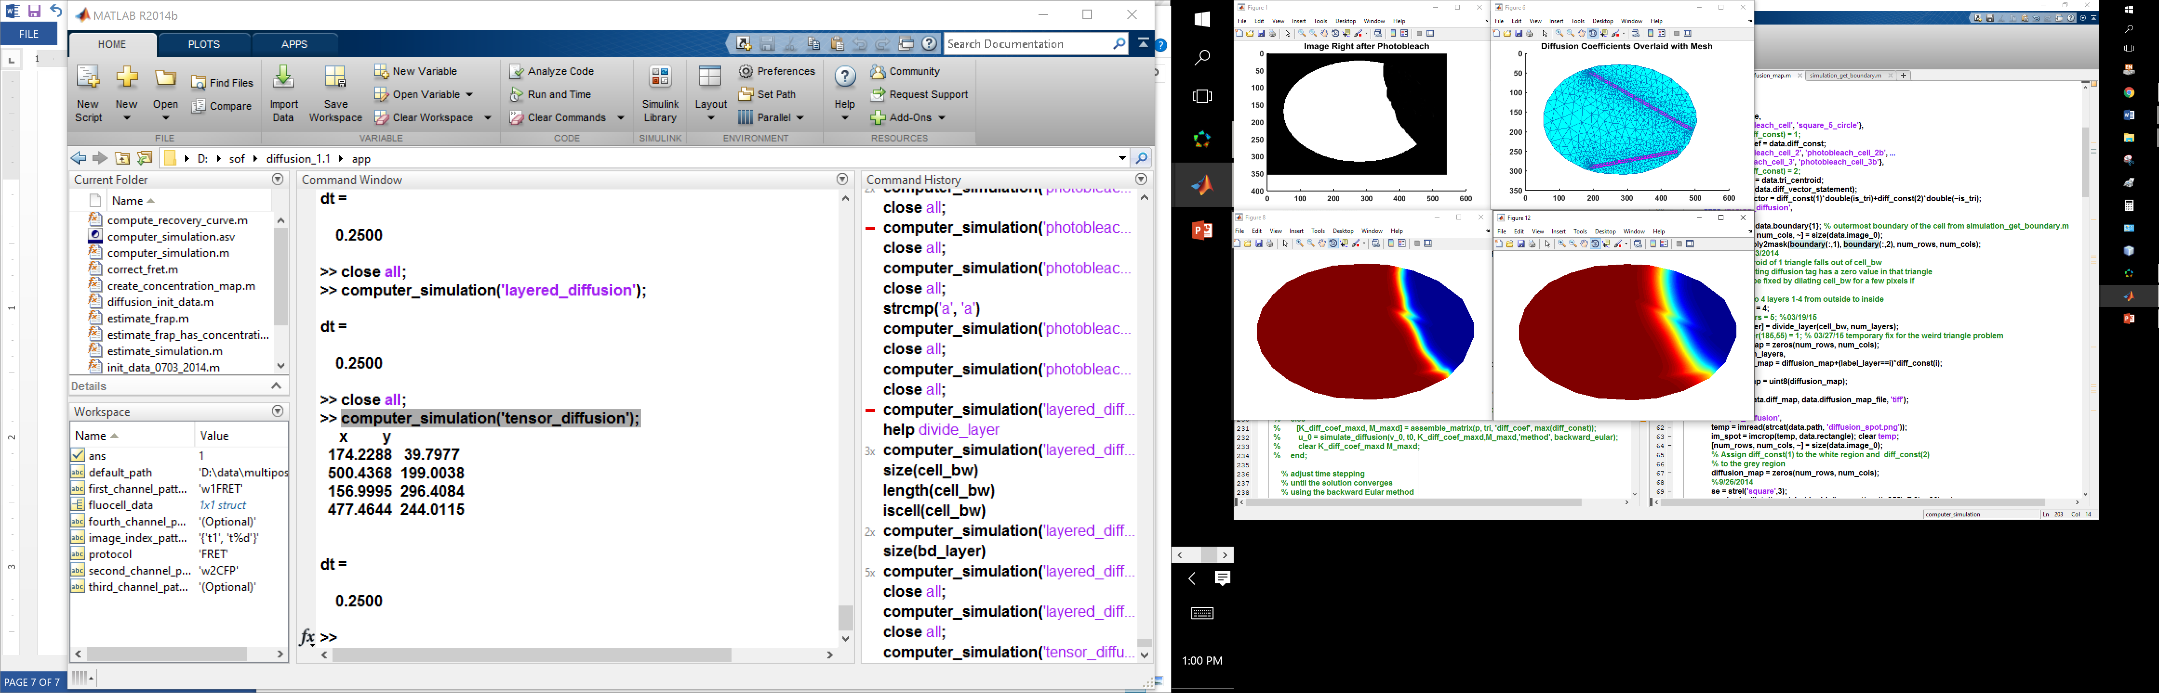>> computer_simulation(data, 'dt', 0.25);

Note that the results has been pre-generated by previous commands.

>> data = sample_diffusion_init_data('photobleach_cell');

>> data = computer_simulation(data, 'dt', 0.25, 'simulation_time', 40);

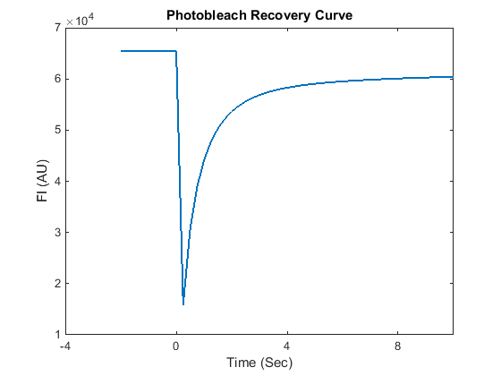>> compute_recovery_curve(data);

**Estimate diffusion coefficients based on frap imaging experiment results**

>> cell_name = 'mem17';

>> data = sample_diffusion_init_data(cell_name);

>> estimate_frap(data);

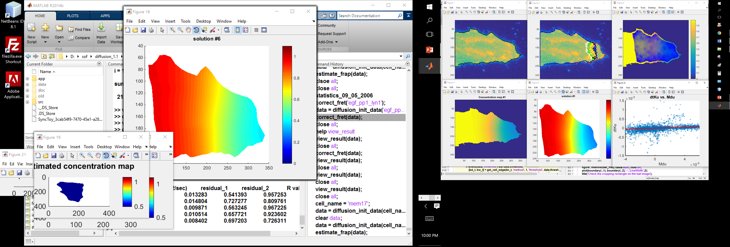

Statistical comparison of the diffusion coefficients.

>> statistics_0905_2006;

**Diffusion correction and save data**

>> cell_name = 'egf_pp1_lyn1';

>> data = sample_diffusion_init_data(cell_name);

>> correct_fret(data);

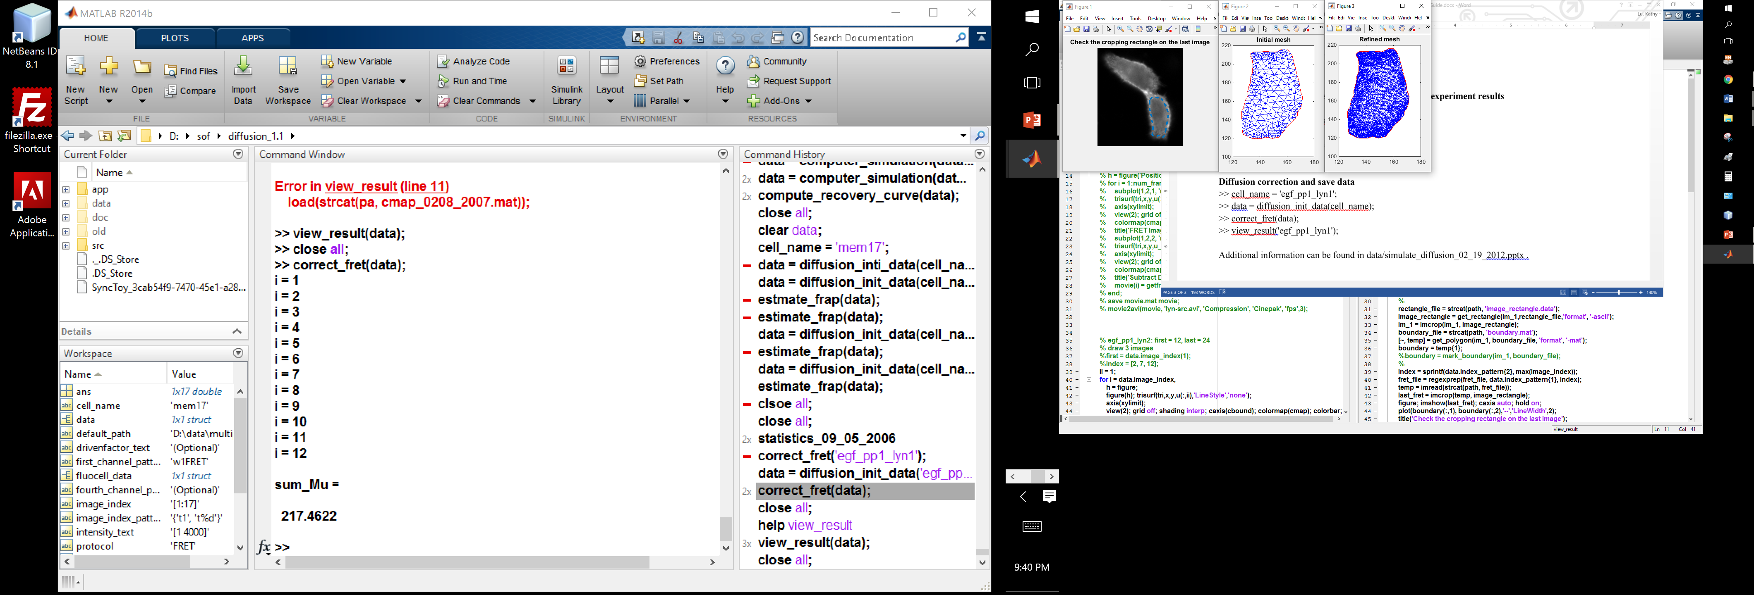

>> view_result(data);

|  |  |  |
| --- | --- | --- |
| Fig. 1 | Fig. 13 | Fig. 26 |